**IBM NALAIYA THIRAN 2022-23 PROJECT REPORT**

**SIGNS WITH SMART CONNECTIVITY**

**FOR BETTER ROAD SAFETY**

**TEAM ID - PNT2022TMID02410**

1. **INTRODUCTION**

# PROJECT OVERVIEW

The primary objective of the project is to create a smart connected sign board that displays speed limits based on the current temperature, weather, and climate as provided by OpenWeatherMap. It will also identify the school zone and hospital zone, which governs the use of the horn.

# PURPOSE

* Keeping people safe is the primary goal of this initiative, and it aims to assist in spreading messages to both drivers and pedestrians that can help to maintain order and lower accident rates.
* Intelligent connected sign boards are used to replace static sign boards.
* The weather conditions will affect speed.
* To lessen accidents, a designated school zone and hospital zone are marked.

1. **LITERATURE SURVEY**

# EXISTING PROBLEM

* Rain renders brakes ineffective, which causes accidents.
* Fog makes it harder to see and raises the risk of accidents.
* Accidents occur because static sign boards cannot change automatically dependent on the weather.

# REFERENCES

1. Chai K. Toh , Juan-Carlos Cano, Carlos Fernandez-Laguia, Pietro Manzon in their paper titled “Wireless digital traffic signs of the future” in the year 2015 proposed a method that recommends traffic signs have come a long way since the first automobile was invented. They have long served the purpose of warning and guiding drivers and also enforcing the traffic laws governing speed, parking, turns, and stopping. In this study, the authors discuss the issues and challenges facing current traffic signs, and how it will evolve into a next-generation traffic sign architecture using advanced wireless communications technologies. With technological advances in the areas of wireless communications and embedded electronics and software, we foresee that, in the future, digital traffic sign posts will be capable of transmitting the traffic sign information wirelessly to road users, and this will transform our roads into intelligent roads, where signs will appear promptly and automatically on in-vehicle displays to alert the driver. There is no longer the need to watch out for traffic signs since the detection will be automatic and performed wirelessly. This transformation will lessen burden on the drivers, so that they can then focus more on the traffic ahead while driving. Also, this evolution into wireless digital sign posts will fit well with the vision of future smart cities,where smart transportation technologies will be present to transform how we drive and commute, yielding greater safety, ease, and assistance to drivers.
2. Eric M. Masatu, Ramadhani Sinde in their paper titled “Development and Testing of Road Signs Alert System Using a Smart Mobile Phone” in the year 2017 propoed that road signs must be visible at a distance that enables drivers to take the necessary actions. However, static road signs are often seen too late for a driver to respond accordingly. In this study, a system for alerting drivers about road signs has been developed and tested using a smart mobile phone. The study was carried out in Tanzania along an 80 km highway stretch from Arusha to Moshi town. The Haversine formula was used to measure and estimate the distance between two pairs of coordinates using the smartphone-based navigation application, Google Map. The application provides a voice alert to a needed action that enhances driver's attention. According to the experimental results, the proposed methodology has the benefits of high accuracy within a user radius of 10 meters, minimum bandwidth, and low-cost application.
3. Fernando, S. Sotheeswaran in their paper titled “Automatic road traffic signs detection and recognition” in the year 2018 proposed that The traffic sign detection and recognition system play an essential role in the intelligent transportation system. On the other hand, most traffic signs are situated on the side of the road, which may have contributed to the collision. Due to the existence of a large background, clutter, fluctuating degrees of illumination, varying sizes of traffic signs, and changing weather conditions, TSDR is an important but difficult process in intelligent transport systems. The objective of this study addresses road traffic sign detection and recognition using a technique that initially detects the bounding box of a traffic sign. Then the detected traffic sign will be recognized for usage in a speeded-up process. Since safe driving necessitates real-time traffic sign detection, the YOLOv4 network was employed in this research. Overall, the work adds by presenting a basic yet effective model for real-time detection and recognition of traffic sign.
4. Dr. Chuen Wan, Hasan Fleyeh in their paper titled “Traffic and Road Sign Recognition” in the year 2008 proposed that This thesis presents a system to recognise and classify road and traffic signs for the purpose of developing an inventory of them which could assist the highway engineers' tasks of updating and maintaining them. All algorithms are tested using hundreds of images and the shadow-highlight invariant algorithm is eventually chosen as the best performer. Based on four shape measures - the rectangularity, triangularity, ellipticity, and octagonality, fuzzy rules were developed to determine the shape of the sign. The final decision of the recogniser is based on the combination of both the colour and shape of the sign. The recogniser was tested in a variety of testing conditions giving an overall performance of approximately 88%. The classification is carried out in two stages: rim's shape classification followed by the classification of interior of the sign. The performance of the SVM was tested using different features, kernels, SVM types, SVM parameters, and moment's orders.
5. G.Vasantha, B.Pavithra, R.Rajagopal in their paper titled “IOT BASED SMART ROADS INTELLIGENT HIGHWAYS WITH WARNING MESSAGE AND DIVERSIONS ACCORDING TO CLIMATE CONDITIONS” in the year 2014 proposed that vehicle accident location by means of sending a message using a system which is placed inside of vehicle system An intelligent Highway is an innovative concept for smart roads of future smart cities. It is a program of innovation that links a different way of looking at things with innovative ideas that apply the opportunities offered by new technologies in smart ways. Nowadays safety on road has become an important factor in our life because there is an increasing amount of accidents on the road and there are some places where accident occur frequently such as crossings, turns. Also there is a big problem of traffic jams on the road. So we are designing a system that is "An Intelligent Highway system with (Weather Accidents Landslides and traffic) W.A.L.T".which is an innovative concept to maintain safety on roads. In this project, we present a low cost innovative technology for smart roads.

**2.3 PROBLEM STATEMENT DEFINITION**

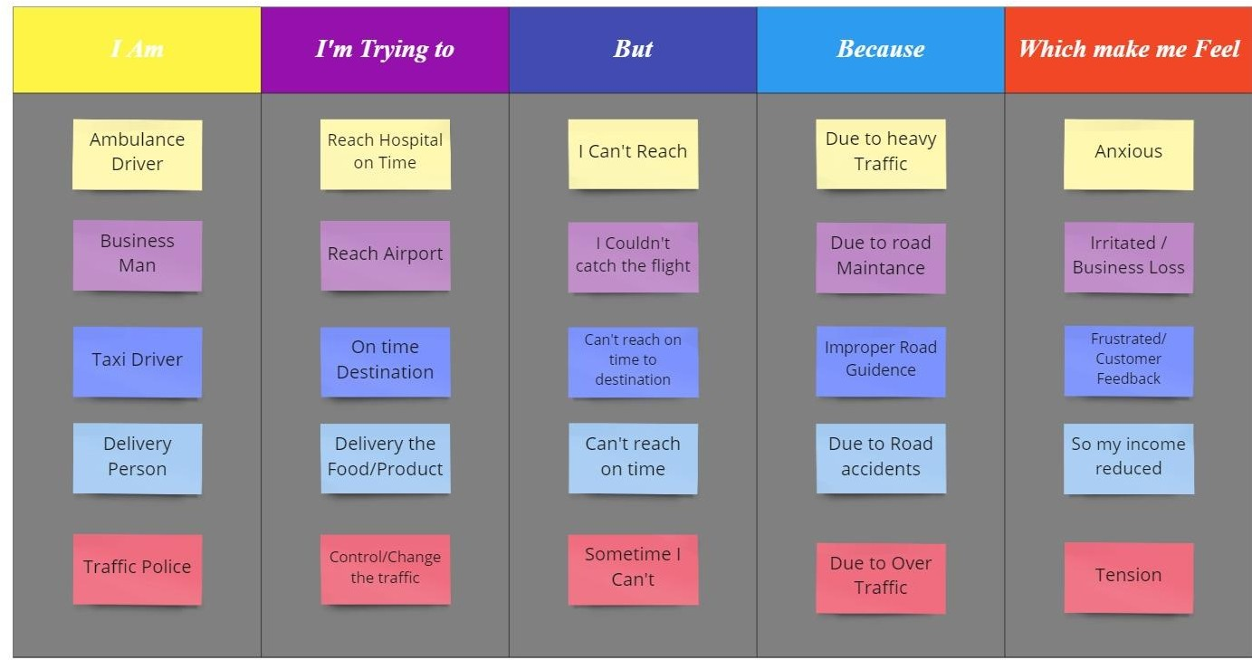

# IDEATION AND PROPOSED SOLUTION

* 1. **EMPATHY MAP CANVAS**

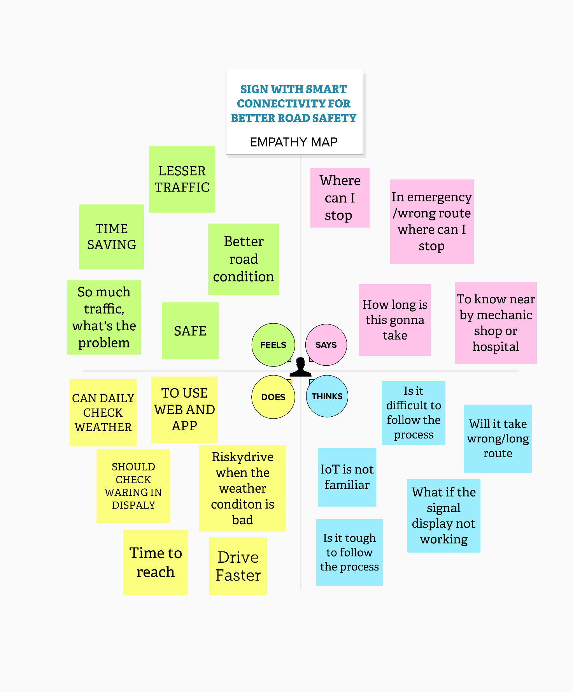

# IDEATION & BRAINSTORMING

# 1. Nowadays we are all travelling with our smartphones. If there is any accident occur in the road we are travelling then it immediately tell other drivers who are travelling in the same road to take the diversion.

# 2. If there is any Ambulance travelling in the same road we are travelling then it immediately send notifications to other users .so that these drivers can give some space to the ambulance.

# 3. Based on the weather condition it indicates the vehicle to decrease the speed limit.

# 4. All traffic lights need to connect to each and every vehicle in the road through IOT. If the traffic light turns red then it indicates every drivers that there is an upcoming red signal inside the car itself.

# 5. Vehicles should have an independent app such that these road signs should be shown in the app. Due to the poor weather condition if the driver is unable to see the traffic signs in the road so that they can see the traffic signs in the app and get alerted.

# PROPOSED SOLUTION

# PROBLEM STATEMENT

* In present system the road sign and speed limits are static. But in case of heavy traffic, road accidents and diversions then we cannot change road signs accordingly based on immediate

1. **IDEA / SOLUTION DESCRIPTION**

* If the road signs are made digitalized or can be changed dynamically, in case of heavy traffic, road accidents and diversions then we can change road signs accordingly. Another http end point is configured to set the direction to be displayed. Upon accessing this http end point, the direction is set remotely for a display using it's unique id.

1. **NOVELTY / UNIQUENESS**

* By using an innovative ways to improve traffic flow, reduce congestion, regulate the patterns of traffic, and create an optimal balance of public and private transportation.

1. **SOCIAL IMPACT / CUSTOMER SATISFACTION**

* We need to explore more cost-effective ways to strengthen the infrastructure. Building roads is expensive. While there is no substitution for new and upgraded roads, smart roadway indicators can be added to increase efficiency.

1. **BUSINESS MODEL (REVENUE MODEL)**

* A primary reason for developing these route is to make the roads safer for all of us. The enhanced signage creates a more efficient experience for drivers. It can also complement the system designs of driverless cars.

1. **SCALABILITY OF THE SOLUTION**

* The value of implementing this technology should not be underestimated. Smart roadway indicators have the potential to increase costefficiency, which eases the burden on governments and taxpayers. They facilitate a smoother driving process for both human drivers and autonomous vehicles.

# PROBLEM SOLUTION FIT

# <https://github.com/IBM-EPBL/IBM-Project-20498-1659721589/blob/main/Project%20Design%20%26%20Planning/Project%20Design%20Phase%201/problem%20solution%20fit.pdf>

# 

# REQUIREMENT ANALYSIS

* 1. **FUNCTIONAL REQUIREMENTS**

|  |  |  |
| --- | --- | --- |
| **FR**  **No.** | **Functional**  **Requirement (Epic)** | **Sub Requirement (Story / Sub-Task)** |
| **FR-1** | **User Visibility** | Guidelines are addressed to policy makers and private companies that are willing to use innovative solutions to decrease road related fatalities and injuries amidst populations |
| **FR-2** | **User Reception** | The potential users of connected technologies, individual drivers, commercial drivers, pedestrians,  cyclists and motorcyclists |
| **FR-3** | **User Understanding** | The task force decided to study first the potential of connected technologies in high and middle  income countries |
| **FR-4** | **User Action** | The user takes the actions like high  income countries are leaders in development of connected vehicles |
| **FR-5** | **Testing** | Testing through components ,Testing  through API and UI |
| **FR-6** | **End Result** | End result through product features,  By using the technology |

# NON-FUNCTIONAL REQUIREMENTS

|  |  |  |
| --- | --- | --- |
| **FR**  **No.** | **Non-Functional**  **Requirement** | **Description** |
| **NFR-1** | **Usability** | In present system the road sign and speed limits are static. But in case of heavy traffic, road accidents and diversions then we cannot change road signs accordingly based on immediate needs for this we can use Signs with Smart Connectivity for Better Road  Safety |
| **NFR-2** | **Security** | If we use sign with smart connectivity for better road safety we can avoid the  traffic and many road accidents |
| **NFR-3** | **Reliability** | We need to explore more cost-effective ways to strengthen the infrastructure. Building roads is expensive. While there is no substitution for new and upgraded roads, smart roadway indicators can be  added to increase efficiency. |
| **NFR-4** | **Performance** | We need to explore more cost-effective ways to strengthen the infrastructure. Building roads is expensive. While there is no substitution for new and upgraded  roads, smart roadway indicators can be added to increase efficiency |
| **NFR-5** | **Availability** | If the road signs are made digitalized or can be changed dynamically, in case of heavy traffic, road accidents and diversions then we can change road signs  accordingly |
| **NFR-6** | **Scalability** | The value of implementing this technology should not be underestimated. Smart roadway indicators have the potential to increase cost efficiency, which eases the burden on governments and taxpayers. They facilitate a smoother driving process for both human drivers and autonomous  Vehicles. |

1. **PROJECT DESIGN**
   1. **DATA FLOW DIAGRAMS**

[**https://github.com/IBM-EPBL/IBM-Project-20498-1659721589/blob/main/Project%20Design%20%26%20Planning/Project%20Design%20Phase%202/Data%20Flow.pdf**](https://github.com/IBM-EPBL/IBM-Project-20498-1659721589/blob/main/Project%20Design%20%26%20Planning/Project%20Design%20Phase%202/Data%20Flow.pdf)

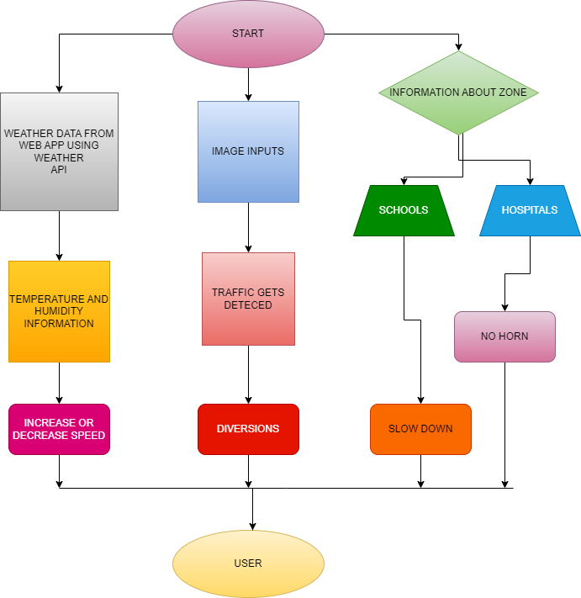

* 1. **SOLUTION & TECHNICAL ARCHITECTURE**

[**https://github.com/IBM-EPBL/IBM-Project-20498-1659721589/blob/main/Project%20Design%20%26%20Planning/Project%20Design%20Phase%202/Technology%20Stack.pdf**](https://github.com/IBM-EPBL/IBM-Project-20498-1659721589/blob/main/Project%20Design%20%26%20Planning/Project%20Design%20Phase%202/Technology%20Stack.pdf)

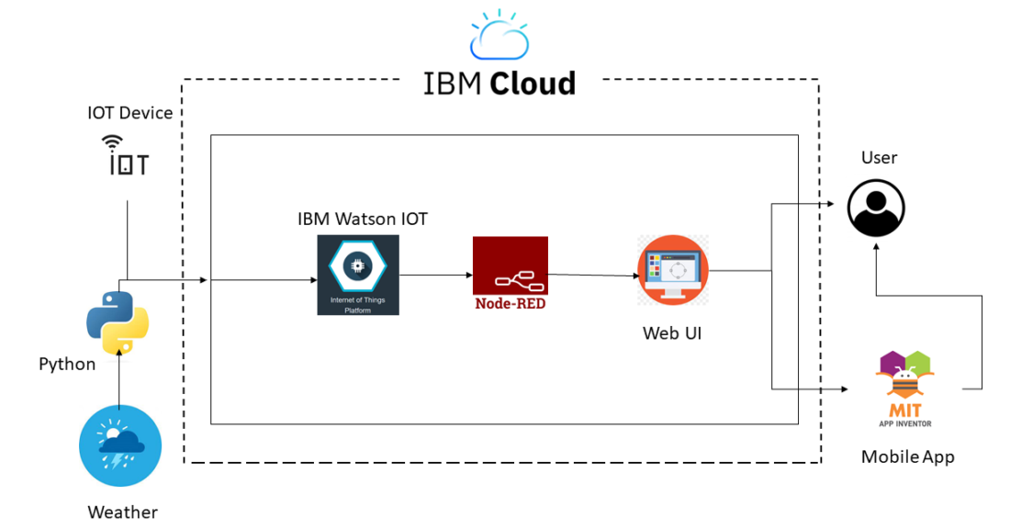

**Table-1 : Components & Technologies:**

|  |  |  |  |
| --- | --- | --- | --- |
| **S.No** | **Component** | **Description** | **Technology** |
| 1. | User Interface | How user interacts with application e.g. Web UI, Mobile App, Chat bot etc. | HTML, CSS, JavaScript / Angular Js / React Js etc. |
| 2. | Application Logic-2 | Logic for a process in the application | IBM Watson STT service |
| 3. | Application Logic-3 | Logic for a process in the application | IBM Watson Assistant |
| 4. | Cloud Database | Database Service on Cloud | IBM DB2, IBM Cloudant etc. |
| 5. | External API-1 | Purpose of External API used in the application | IBM Weather API, etc. |

**Table-2: Application Characteristics:**

|  |  |  |  |
| --- | --- | --- | --- |
| **S. No** | **Characteristics** | **Description** | **Technology** |
| 1. | Security Implementations | Strong security system that anyone without login  credentials and hackers are not allowed to enter the network. | Firewall, Firebase, cyber resiliency strategy |
| 2. | Scalable Architecture | Easy to expand the operating range by increasing the bandwidth of the  network. | IOT, Internet |
| 3. | Availability | Available anytime and everywhere 24/7 as long as the user is signed  into the network. | IBM Cloud |
| 4. | Performance | Supports a large number of users to access the technology simultaneously. | IBM Cloud |

* 1. **USER STORIES**

**Customer Journey –**

<https://github.com/IBM-EPBL/IBM-Project-20498-1659721589/blob/main/Project%20Design%20%26%20Planning/Project%20Design%20Phase%202/Custom%20Journey.pdf>

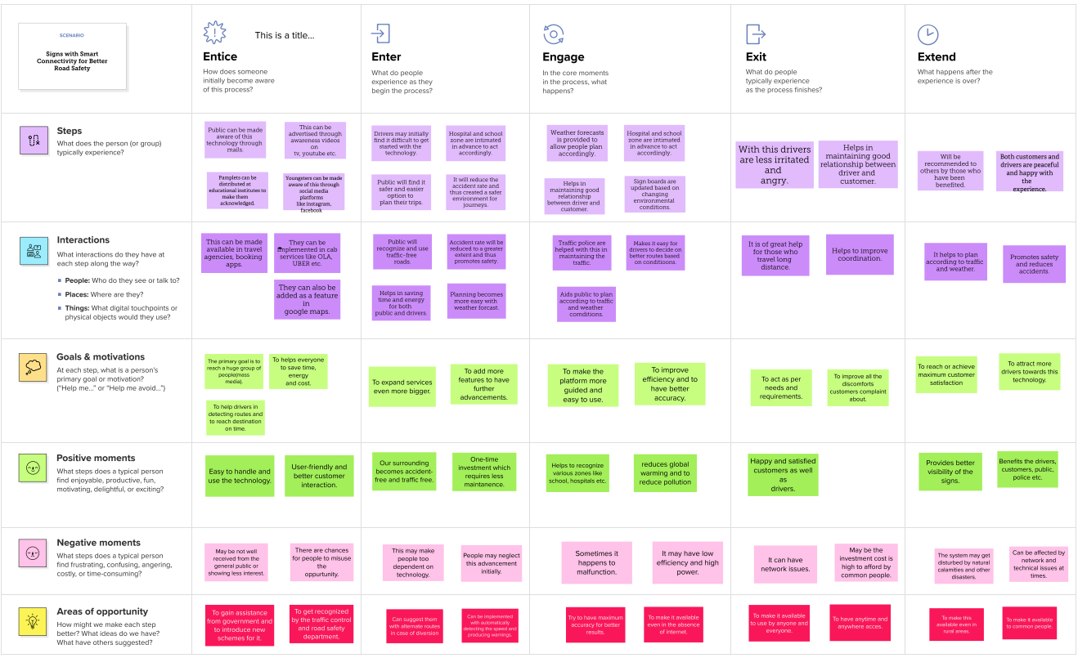

# PROJECT PLANNING AND SCHEDULING PHASE

* 1. **SPRINT PLANNING & ESTIMATION**

<https://github.com/IBM-EPBL/IBM-Project-20498-1659721589/tree/main/Project%20Design%20%26%20Planning/Project%20planning%20phase>

# Product Backlog, Sprint Schedule, and Estimation (4 Marks)

Use the below template to create product backlog and sprint schedule

|  |  |  |  |  |  |  |
| --- | --- | --- | --- | --- | --- | --- |
| **Sprint** | **Functional Requirement (Epic)** | **User Story Number** | **User Story / Task** | **Story Points** | **Priority** | **Team Members** |
| Sprint-1 | Registration | USN-1 | As a user, I can register for the application by entering my email, password, and confirming my password. | 2 | High | Saranmony Haakash Hemanth  Kammaatchi |
| Sprint-1 |  | USN-2 | As a user, I will receive confirmation email once I have registered for the application | 1 | High | Saranmony Haakash Hemanth  Kammaatchi |
| Sprint-1 |  | USN-3 | As a user, I can register for the application through Facebook | 2 | Low | Saranmony Haakash Hemanth  Kammaatchi |
| Sprint-1 |  | USN-4 | As a user, I can register for the application through Gmail | 2 | Medium | Saranmony Haakash Hemanth  Kammaatchi |

|  |  |  |  |  |  |  |
| --- | --- | --- | --- | --- | --- | --- |
| **Sprint** | **Functional**  **Requirement (Epic)** | **User Story Number** | **User Story / Task** | **Story Points** | **Priority** | **Team Members** |
| Sprint-1 | Login | USN-5 | As a user, I can log into the application by entering email & password | 1 | High | Saranmony Haakash Hemanth  Kammaatchi |
| Sprint-1 | Dashboard | USN-6 | As a user, I can log into the application by entering email & password and access all the resources and services available | 2 | High | Saranmony Haakash Hemanth  Kammaatchi |

|  |  |  |  |  |  |  |
| --- | --- | --- | --- | --- | --- | --- |
| **Sprint** | **Functional**  **Requirement (Epic)** | **User Story Number** | **User Story / Task** | **Story Points** | **Priority** | **Team Members** |
| Sprint-2 | Login | USN-1 | As a weather data controller, I log into my profile and start monitoring the weather updates | 3 | High | Saranmony Haakash Hemanth  Kammaatchi |
| Sprint-2 | Dashboard | USN-2 | I receive all the information about weather from web from weather API. Whenever there is change in weather, corresponding updates are made on sign boards. | 2 | Medium | Saranmony Haakash Hemanth  Kammaatchi |
| Sprint-3 | Login | USN-1 | As a image controller, I keep note of all the images received from various areas and detect traffic in that particular area. | 3 | High | Saranmony Haakash Hemanth Kammaatchi |

|  |  |  |  |  |  |  |
| --- | --- | --- | --- | --- | --- | --- |
| **Sprint** | **Functional**  **Requirement (Epic)** | **User Story Number** | **User Story / Task** | **Story Points** | **Priority** | **Team Members** |
| Sprint-3 | Dashboard | USN-2 | With the traffic, updates I change the status of sign board as “take diversion”. | 2 | Medium | Saranmony Haakash Hemanth  Kammaatchi |
| Sprint-4 | Login | USN-1 | As a zonal officer, I ensure that boards near school display “slow down” and near hospitals display “no horn”. | 3 | High | Saranmony Haakash Hemanth  Kammaatchi |
| Sprint-4 | Login | USN-1 | As an administrator, I ensure that all departments work co-ordinated and ensure the accuracy and efficiency. | 2 | Medium | Saranmony Haakash  Hemanth Kammaatchi |

# Project Tracker, Velocity & Burndown Chart: (4 Marks)

|  |  |  |  |  |  |  |
| --- | --- | --- | --- | --- | --- | --- |
| **Sprint** | **Total Story Points** | **Duration** | **Sprint Start Date** | **Sprint End Date (Planned)** | **Story Points Completed (as on**  **Planned End Date)** | **Sprint Release Date (Actual)** |
| Sprint-1 | 20 | 6 Days | 24 Oct 2022 | 29 Oct 2022 | 20 | 29 Oct 2022 |
| Sprint-2 | 20 | 6 Days | 31 Oct 2022 | 05 Nov 2022 |  |  |
| Sprint-3 | 20 | 6 Days | 07 Nov 2022 | 12 Nov 2022 |  |  |
| Sprint-4 | 20 | 6 Days | 14 Nov 2022 | 19 Nov 2022 |  |  |

# SPRINT DELIVERY SCHEDULE

<https://github.com/IBM-EPBL/IBM-Project-20498-1659721589/tree/main/Project%20Design%20%26%20Planning/Project%20planning%20phase>

# JIRA REPORT

# BURNDOWN CHART

# Burndown chart

# JIRA TIMELINE

# 

# CODING & SOLUTIONING

**7.1 NODE RED**

# Information is obtained from the IBM IoT Watson in this instance utilizing the IBM IoT node. We can access the function to display the items from the IBM IoT node. To show the output, we had connected the function to the text and gauges on the dashboard.

# 

**Node Red Dashboard:**

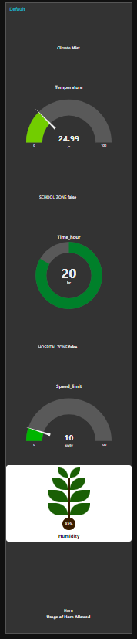

**7.2 User interface**

**MIT APP UI:**

[**http://ai2.appinventor.mit.edu/#5384690568396800**](http://ai2.appinventor.mit.edu/%235384690568396800)

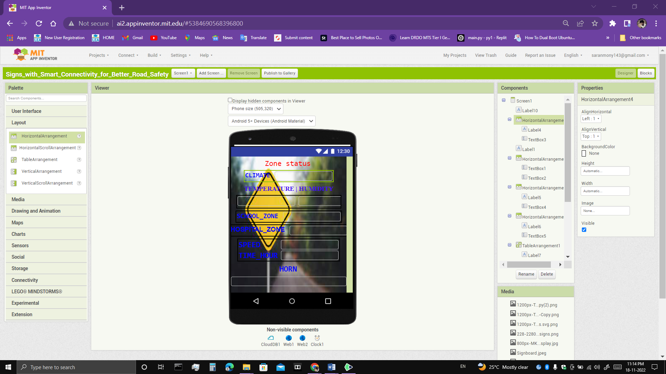

**MIT APP Block Code:**

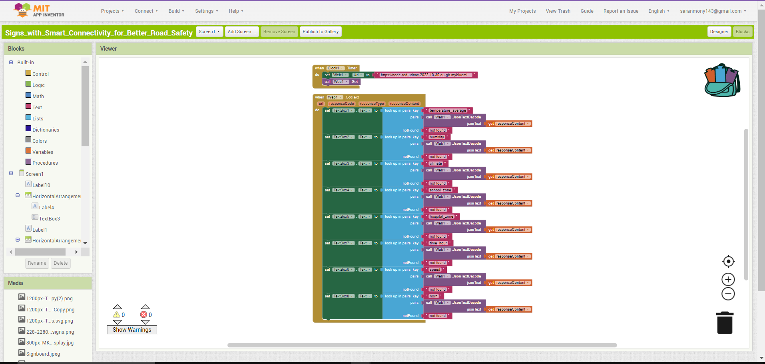

**MIT APP Output:**

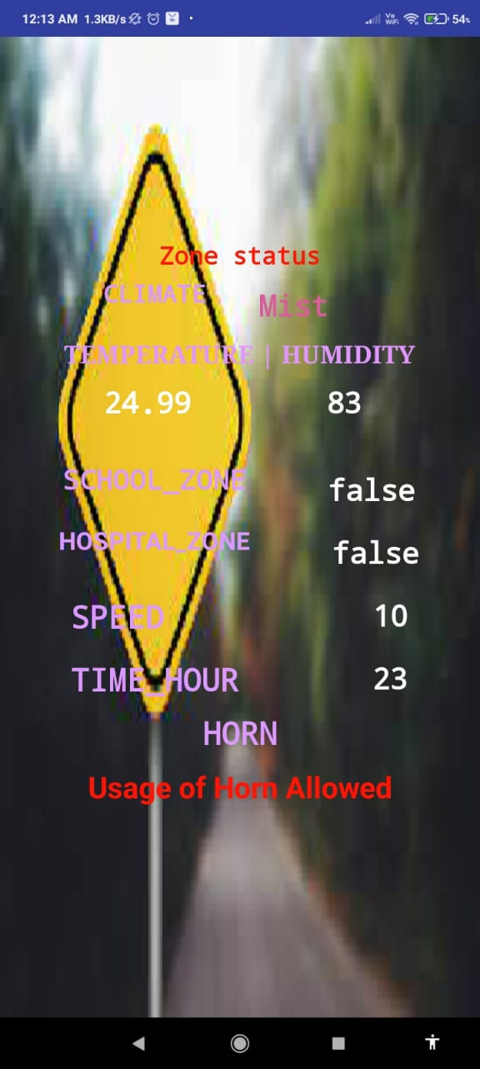

1. **TESTING**
   1. **TEST CASES**

* **TEST CASE 1**

Clear weather - Usual Speed Limit.(60 km/h)

# TEST CASE 2

Snow/Fog – Speed limkit is reduced to 10 km/h.

# TEST CASE 3

Rainy Weather – Set speed limit to 15 km/h.

# TEST CASE 4

School/Hosipital Zone – Usage of horn not allowed.

# USER ACCEPTANCE TESTING

# Purpose of Document

The purpose of this document is to briefly explain the test coverage and open issues of the **Zone status** project at the time of the release to User Acceptance Testing (UAT).

# Defect Analysis

This report shows the number of resolved or closed bugs at each severity level, and how they were resolved

|  |  |  |  |  |  |
| --- | --- | --- | --- | --- | --- |
| **Resolution** | **Severity 1** | **Severity 2** | **Severity 3** | **Severity 4** | **Subtotal** |
| By Design | 1 | 0 | 0 | 0 | 1 |
| Duplicate | 0 | 0 | 0 | 0 | 0 |
| External | 0 | 0 | 0 | 0 | 0 |
| Fixed | 1 | 0 | 0 | 0 | 1 |
| Not Reproduced | 0 | 0 | 0 | 0 | 0 |
| Skipped | 0 | 0 | 0 | 0 | 0 |
| Won't Fix | 0 | 0 | 0 | 0 | 0 |
| Totals | 2 | 0 | 0 | 0 | 2 |

# Test Case Analysis

This report shows the number of test cases that have passed, failed, and untested

|  |  |  |  |  |
| --- | --- | --- | --- | --- |
| **Section** | **Total Cases** | **Not Tested** | **Fail** | **Pass** |
| Print Engine | 2 | 1 | 0 | 1 |
| Client Application | 1 | 0 | 0 | 1 |
| Security | 2 | 0 | 0 | 2 |
| Outsource Shipping | 3 | 0 | 0 | 3 |
| Exception Reporting | 2 | 0 | 0 | 2 |
| Final Report Output | 2 | 0 | 0 | 2 |
| Version Control | 1 | 0 | 0 | 1 |

# RESULTS

* 1. **PERFORMANCE METRICS**

Depending on the IBM package we chose, the website's functionality varies. NodeRED, a lightweight and powerful engine based on NodeJS, can process up to 10,000 requests per second. Additionally, more consumers can be accommodated because the system is expandable horizontally.

# ADVANTAGES & DISADVANTAGES

**10.1 ADVANTAGES**

* Based on the current weather, the system is automatically updated.
* Maintenance cost is minimum
* Lower battery consumption and fuel consumption
* High processing speed
* Efficient
* Can enhance security measures on roads
* Improve traffic flow

**10.2 DISADVANTAGES**

* Security issues
* Power consumption

# CONCLUSION

Our initiative can be put into practice very soon and can replace static signs at a far reduced price. The number of accidents will be greatly decreased as a result, and the nation's traffic will remain calmer overall.

1. **FUTURE SCOPE**

# Numerous sensors and analytics are used in smart road technology to enhance transit, optimize routes, and spot accidents. Through route optimization and accident detection, smart road technology has the ability to enhance mobility overall. There are still some issues with this technology's limits, though

1. **APPENDIX**

**GITHUB AND PROJECT DEMO LINK –** [**https://github.com/IBM-EPBL/IBM-Project-20498-1659721589**](https://github.com/IBM-EPBL/IBM-Project-20498-1659721589)

# DEMO VIDEO DOWNLOAD LINK – <https://github.com/IBM-EPBL/IBM-Project-20498-1659721589/blob/main/Final%20Deliverable/Demo_video.mp4>

# SOURCE CODE - <https://github.com/IBM-EPBL/IBM-Project-20498-1659721589/blob/main/Final%20Deliverable/Final_python_code.py>

import json

import os

import random as rd

import sys

import time

from datetime import datetime as dt

import ibmiotf.application

import ibmiotf.device

import requests as req

# Weather Details

api_key = "f3907e39a60a6c7384c1221a8eb634af"

city = "Chennai"

country = "IN"

url_w=f"https://api.openweathermap.org/data/2.5/weather?q={city},{country}&appid={api_key}&units=metric"

# Cloud Details for weather

org_id_w = "fdrxjb"

device_type_w = "Weather"

device_id_w = "Weather_iot"

auth_method_w = "token"

auth_token_w = "Climate_123"

# Datas Needed

default_speed_limit = 60 # km/hrs

default_horn = True # Horn can be used

hour_now = int(str(dt.now()).split()[1].split(":")[0])

today = str(dt.now().strftime("%A"))

# Location Information

location_info = {

     "school" :  {

        "school_zone" : False, # Randomize Zones

        "active_time" : [7,17] # 7 am - 5 pm

        }

        ,

    "hospitals_near_by" :{

        'hospital_zone':False}, # Randomize Zones

    "speed_limit" : default_speed_limit,

    "horn" : default_horn

    }

def get_weather_details():

    weather_req = req.get(url = url_w)

    weather_data = weather_req.json()

    climate = weather_data['weather'][0]['main']

    humidity = weather_data['main']['humidity']

    pressure = weather_data['main']['pressure']

    temperature = weather_data['main']['temp']

    temperature_min = weather_data['main']['temp_min']

    temperature_max = weather_data['main']['temp_max']

    temperature_feel = weather_data['main']['feels_like']

    temperature_average = (temperature_max+ temperature_min)/2

    data = {'climate':climate,'humidity':humidity,'temperature_average':temperature_average}

    return data

def myonpublishcallback_w(data):

    print(f"Published Temperature  = { data['temperature_average'] }, Humidity = {data['humidity']}, Climate = {data['climate']}")

def myonpublishcallback_s(speed_horn_data):

    print()

    print(f"Speed limit  = { speed_horn_data['speed'] }")

    print(f"Horn Info = {speed_horn_data['Horn']}")

    print(f"hospital_zone = {speed_horn_data['hospital_zone']}")

    print(f"school_zone = {speed_horn_data['school_zone']}")

    print(f"Time Now (in hrs) = {speed_horn_data['time_hour']}")

    print()

# Speed Limit and Horn Process

def speed_process(climate):

    #print(climatee)

    #print(location_info)

    if climate == 'Rain':

        if location_info['hospitals_near_by']['hospital_zone']:

            location_info['horn'] = False

            location_info['speed_limit'] = 15

        elif location_info['school']['school_zone']:

            if today == "Sunday":

                location_info['horn'] = default_horn

                location_info['speed_limit'] = 25

            else:

                if location_info['school']['active_time'][0] >= hour_now  and location_info['school']['active_time'][1]<=hour_now :

                    location_info['horn'] = False

                    location_info['speed_limit'] = 15

                else:

                    location_info['horn'] = default_horn

                    location_info['speed_limit'] = 25

        else:

            location_info["horn"] = default_horn

            location_info["speed_limit"] = 20

    elif climate == 'Snow' or climate == 'Smog' or climate == 'Fog':

        location_info['speed_limit'] = 10

        if location_info['hospitals_near_by']['hospital_zone']:

            location_info['horn'] = False

        elif location_info['school']['school_zone']:

            if today == "Sunday":

                location_info['horn'] = default_horn

            else:

                if location_info['school']['active_time'][0] >=hour_now  and location_info['school']['active_time'][1]<=hour_now :

                    location_info['horn'] = False

                else:

                    location_info['horn'] = default_horn

        else:

            location_info["horn"] = default_horn

    else:

        if location_info['hospitals_near_by']['hospital_zone']:

            location_info['horn'] = False

            location_info['speed_limit'] = 20

        elif location_info['school']['school_zone']:

            if today == "Sunday":

                location_info['horn'] = default_horn

                location_info['speed_limit'] = default_speed_limit

            else:

                if (location_info['school']['active_time'][0] >=hour_now ) and (location_info['school']['active_time'][1]<=hour_now) :

                    location_info['horn'] = False

                    location_info['speed_limit'] = 20

                else:

                    location_info['horn'] = default_horn

                    location_info['speed_limit'] = default_speed_limit

        else:

            location_info['horn'] = default_horn

            location_info['speed_limit'] = default_speed_limit

# Connecting to weather cloud

try:

    deviceOptions_w = {"org" : org_id_w,

                     "type" : device_type_w,

                     "id" : device_id_w,

                     "auth-method" : auth_method_w,

                     "auth-token" : auth_token_w

                    }

    deviceCli_w = ibmiotf.device.Client(deviceOptions_w)

except Exception as e:

    print("Caught exception connecting device {str(e)}")

    sys.exit()

deviceCli_w.connect()

# Processing

while True:

    location_info['hospitals_near_by']['hospital_zone']=rd.choice([True,False])

    location_info['school']['school_zone']=rd.choice([True,False])

    climate_status=rd.choice(["Rain","Fog","Mist","Smog","Snow"])

    print(climate_status)

    data = get_weather_details()

    speed_process(climate_status)

    horn_data = "Usage of Horn Allowed" if location_info['horn'] else "Do not use the horn frequently"

    speed_horn_data = {"hospital_zone":location_info['hospitals_near_by']['hospital_zone'],"school_zone":location_info['school']['school_zone'],"time_hour":hour_now,"speed":location_info['speed_limit'],"Horn":horn_data}

    for key in speed_horn_data:

        data[key] = speed_horn_data[key]

    success_w = deviceCli_w.publishEvent("Current Weather","json",data,qos=1,on_publish = myonpublishcallback_w(data))

    print(data)

    if not success_w :

        time.sleep(1)

    time.sleep(3)